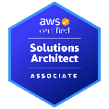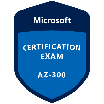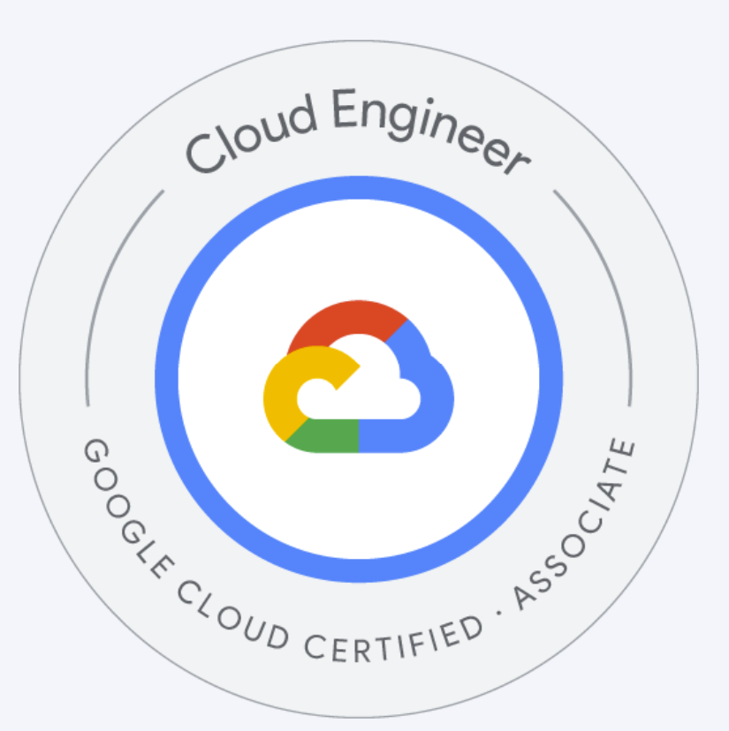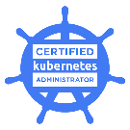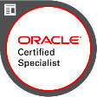

Cloud/DevOps/Infrastructure Engineer | Cloud Solutions Architect | Middleware Architect | Platform Engineer | Site Reliability Engineer (SRE)

Leela Lakshman Sai Gurram
Phoenix, AZ
Mobile: +1 623-748-7487
Email: lakshman.cloudwork@gmail.com

Summary of Experience and Qualifications

With 14 years of experience in the IT industry, I have extensive expertise in Client/Server Applications, Middleware tools support, and infrastructure management. As a Principal Engineer, I have worked on both on-premises and cloud-based infrastructure, specializing in the architecture, design, and development of high-availability, high-performance, and scalable Java J2EE enterprise applications in clustered environments. I have been responsible for addressing enterprise security audits, including infrastructure and application vulnerabilities, data security, and user audits, and successfully remediate them across clusters. My core expertise spans Kubernetes, OpenShift, Ansible, Terraform, cloud-based identity solutions, and DevOps methodologies

My experience spans financial services, where I delivered cost-effective infrastructure and platform services to support developers' cloud adoption journeys, and semiconductor and higher education sectors, where I contributed to advanced process automation and learning environments. I have extensive experience with MAPR Big Data, ELK Stack, Kafka, Puppet, Collibra, MuleSoft, JBoss EAP, and the Oracle middleware stack (WebLogic, JMS, ESB, SOA, OAM, OIM), along with various open-source tools, cloud technologies, and automation frameworks. I am proficient in scripting languages like Unix Shell and Python, ensuring optimized infrastructure management and automation

Certifications:
- Amazon Solution Architect
- Google Cloud Engineer (GCP)
- Certified kubernetes Administrator CKA
- Microsoft Azure Architect Technologies
- Oracle Autonomous Database Cloud Certified

Experience:

American Express, Phoenix AZ
Senior Cloud Engineer APR 2025 – TILL DATE

Role: Senior member of a CI/CD operations team. Held sole responsibility for all cloud-based Automation, resources management, build and deployments

- Managed and optimized Kubernetes Rancher clusters, ensuring high availability of Linux-based CI/CD environments. Automated system tasks using Bash and Ansible, and monitored system health to address disk, process, and log-related issues.
- Collaborated with engineering teams during the Rancher upgrade to RKE2, ensuring a seamless transition by addressing compatibility issues and validating cluster configurations. Coordinated testing and deployment to minimize downtime and maintain system reliability.
- Removed unused directories and redundant files post-upgrade to reclaim disk space on runners and MUP clusters. This optimization improved system performance and ensured sufficient storage for future workloads.
- Designed and maintained Jenkins pipelines integrated with Artifactory. Managed plugins, performed version upgrades, optimized job execution, and implemented secure credential handling.
- Diagnosed and resolved network issues affecting CI/CD pipelines, including DNS, firewall, proxy, and SSL/TLS problems. Utilized tools like tcpdump, curl, and netstat for analysis and maintenance.
- Administered Splunk for log management, creating dashboards and alerts for system performance. Managed Dynatrace for real-time application monitoring and ensured observability for Jenkins, Artifactory, and infrastructure components.
- Developed CI/CD pipelines using Jenkins, Ansible, and testing tools to automate infrastructure deployment. Configured Jenkins servers and nodes, creating automation scripts in Python and Perl to enhance CI workflows. Automated scripts for build server workspace cleanup, ensuring efficient use of disk space and preventing build failures due to storage limitations.
- Managed application testing tools such as Sauce Labs, SonarQube, JMeter, and LISA to support quality assurance processes.
- Implemented proactive monitoring and alerting mechanisms to identify and resolve system bottlenecks, improving overall reliability and performance.Utilized GitHub for version control, repository management, and collaboration. Implemented branching strategies, pull request workflows, and automated actions to streamline development processes.

Technical Environment: Kubernetes, Rancher, DevOps, Ansible, CI/CD, Prometheus, Grafana,, Jenkins, Sauce labs , Sonor Qube, ELK stack, Splunk, Dynatrace

TSMC Arizona Cooperation, Phoenix AZ
Principal Engineer / Cloud Architect AUG’ 22 – APR 2025

Modernize web-based application that enables all Fab tools ETCH process automation and maintenance all activities of manufacturing plant

Role: Architect, develop (Infrastructure-as-Code, CI/CD pipelines), deploy or configure infrastructure, Kubernetes, and CI/CD pipelines as part of the overall modernized application architecture.

- Worked closely with cross-functional teams to push for process improvements, fighting against inevitable downtime and quality compromises in a high-pressure, high-volume production environment.
- Architected and deployed containerized applications using Docker and Kubernetes, ensuring scalability, high availability, and secure deployments.
- Integrated Backstage with AWS Infrastructure – Connected Backstage with AWS Service Catalog, Terraform, and CloudFormation to allow developers to provision infrastructure efficiently through the unified portal.
- Integrated Google Cloud Armor for network security and protection against application-layer attacks.
- Developed and enforced cloud security policies for containerized applications, reducing vulnerabilities by 30%.
- Managed Google Kubernetes Engine (GKE) clusters, optimizing networking, security, and scalability.
- Administered Docker-based infrastructure, including Swarm and Hub, optimizing performance and scalability for enterprise applications.
- Managed Kubernetes charts using Helm, creating reproducible builds of Kubernetes applications, and overseeing Kubernetes deployment and service files.
- Integrated EKS and ECS for seamless orchestration and scaling of workloads across cloud platforms.
- Performed cost optimization by analysing GCP resource usage and refining infrastructure scaling strategies.
- Led cloud migration efforts, ensuring minimal downtime and smooth transition to GCP.
- Collaborated with cross-functional teams to architect observability pipelines for GCP services like GKE, Cloud Run, and BigQuery.
- Led Hadoop cluster performance optimization, including capacity planning, monitoring cluster connectivity, and ensuring security.
- Developed and implemented Canary Proof of Concept (POC). Created Harness CD workflows and pipelines to support Canary deployments

Technical Environment: Kubernetes, Cloudera, DevOps, Ansible, CI/CD, Prometheus, Grafana, MATLAB, AUTOCAD, GCP, Docker, Terraform, Jenkins, Istio, Gloo Mesh, Google Cloud Armor, Helm, Hadoop

American Express, Phoenix, AZ
Sr. System Engineer/ Cloud Engineer/ Middleware Architect OCT 2015 – AUG 2022

Role: Senior member of a middleware infrastructure team. Held sole responsibility for all cloud-based resources including identity; infrastructure-, Platform, Functions- and software services.

- Designed and implemented automation processes for server builds, migrations, and patching across on-prem and cloud environments (GCP, VMware).
- Automated configuration management using Ansible and Puppet, reducing manual intervention and streamlining deployments in hybrid cloud environments.
- Implemented Kubernetes clusters for microservices and enterprise applications, enhancing scalability and flexibility for Tomcat and JBoss services.
- Managed Docker container lifecycle from creation to deployment and monitoring, optimizing resource utilization and operational efficiency.
- Led cloud-native application migration to Kubernetes, deploying ML applications on Google Kubernetes Engine (GKE).
- Designed and implemented robust CI/CD pipelines with Jenkins, Terraform, and GitOps to automate application and infrastructure deployments, enabling faster time-to-market.
- Integrated infrastructure provisioning with Terraform to standardize and reuse cloud configurations across compute, storage, and networking resources in GCP.
- Led the migration of legacy applications to cloud-native architectures, leveraging Kubernetes and GKE for enhanced scalability and performance.
- Optimized cloud resource utilization and cost by analyzing GCP billing reports, adjusting auto-scaling policies, and implementing performance benchmarks.
- Integrated Splunk and Dynatrace for proactive monitoring, anomaly detection, and log analytics across cloud and on-prem environments.
- Enforced Google Cloud IAM policies, role-based access control (RBAC), and implemented GCP-native security measures such as Google Cloud Armor, VPC Service Controls, and Identity-Aware Proxy (IAP).
- Developed APIs to expose OpenShift services to end users, enabling the consumption of Kubernetes resources as Infrastructure as a Service (IaaS).
- Managed VMware vSphere environments, including VM provisioning and performance optimization.
- Led the upgrade/migration of RHEL versions using Satellite Server and Capsule Server, contributing to improved system stability and security.
- Documented best practices and runbooks for infrastructure management, including storage inventory, volume allocation, and performance monitoring.

Technical Environment: BIGDATA, MAPR 5.x/6.x, VMware, ESX, ESXi, Linux, Splunk, ICINGA, Kubernetes, OpenShift, Docker, Puppet, Terraform, Jenkins, GCP, Ansible, Tomcat, JBoss, Oracle, Apache Solr, Elasticsearch, Redis, Google Cloud IAM, Dynatrace.

Choice Hotels, Scottsdale AZ
Sr Oracle Middleware Administrator OCT 2014 - OCT 2015

Role: Architecting, implementing and maintaining hardware and software related to and maintaining applications and content on the choice of booking portals.

- Performance tuning by managing and monitoring JVM performance through adjustments to Java heap size, garbage collection, execute threads, EJB cache size, JDBC pools, and multi-pools. Actively involved in upgrading to new service packs for WebLogic, Sun ONE, iPlanet, and Apache/Tomcat.
- Led the migration of services from OpenStack VMs to redesigned implementations and redeployment of Nagios, with automated node addition/deletion via Puppet.
- Conducted performance tuning of JVM heap size, garbage collection, Java stack, and native thread production performance. Managed the migration of WebLogic servers from previous versions to current versions.
- Researched and troubleshot emerging application issues, ranging from WebLogic configuration problems to code-related issues. Performed thread dump and heap dump analysis for WebLogic application servers. Experienced with Oracle WebLogic and UNIX shell scripting.

Technical Environment: WebLogic Server 8.1/9.2/10.3/11g/12c, SUN Solaris 8.0/10.0, Linux, Oracle 9i/8i, Splunk, JDK 1.4/1.5,1.6, JDBC 2.0, Servlets, EJB 2.0, Apache,

Client: T-Mobile, Seattle, WA Oct 2013 - Sep 2014
Client: FedEx Express, Memphis Nov 2011 - Oct 2013

Roles: Oracle Middleware /Applications Analyst

- Provided 24x7 production support for multiple applications across various business areas. Installed, configured, and administered WebLogic Server 7.x/9.x/10.3.x/11g on Red Hat Linux 5.x and Windows environments.
- Led the administration, installation, and configuration of the Oracle SOA Suite. Gained experience in deploying the SOA Suite using Stage, No-Stage, and External Stage modes. Utilized pack and unpack commands for domain creation across Dev, QA, UAT, PP, and Production environments.
- Installed and configured SSL certificates for Apache web servers across various environments. Administered WebLogic Server in conjunction with Oracle9i/10g databases.
- Deployed applications on multiple WebLogic servers, ensuring load balancing, high availability, and failover functionality. Created and configured data sources for database connectivity and JMS resources.

Technical Skills:

Infrastructure as Code (IaC) & Automation: Terraform, Ansible, Puppet
Cloud Platforms: Google Cloud Platform (GCP), Microsoft Azure, AWS
Containerization & Orchestration: Kubernetes (GKE, EKS, OpenShift), Docker
CI/CD & DevOps: Jenkins, GitOps, Harness CD
Monitoring & Logging: Splunk, Dynatrace, Prometheus, Grafana, ELK Stack, Kibana, ICINGA, Wily Introscope, HP SiteScope, OEM 11g
Networking & Security: Google Cloud Armor, IAM Policies, RBAC, VPC, Load Balancing, API Gateway
Middleware & Messaging: Apache, Tomcat, JBoss/Wildfly, JBoss EAP, Oracle Middleware Stack, MuleSoft, Collibra, ESB, SOA, Kafka, JMS
Operating Systems: Red Hat Linux, Windows, Solaris
Scripting & Programming Languages: Unix Shell, Python
Database & Big Data Technologies: Oracle, ELK Stack, Hive, HBase, HDFS, Solr, Redis, MongoDB, Hadoop, MAPR
Change & ITSM Tools: ServiceNow, Remedy, JIRA, Confluence

Education Details
- Master’s Degree in Biological Science from Illinois Institute of Technology 2008-2010
- Bachelors in biotechnology from JNTU Hyderabad, India 2003-2007

